 |  | 

U N I T E D S T A T E S A I R F O R C E
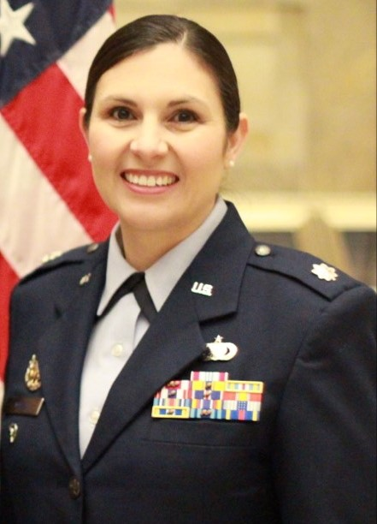
LIEUTENANT COLONEL DORINDA M. MAZZA

Lieutenant Colonel Dorinda M. Mazza is the Deputy Director, Air Force Congressional Budget and Appropriations Liaison, Office of the Deputy Assistant Secretary of the Air Force for Financial Management and Comptroller, the Pentagon, Washington D.C. In this role, she leads a staff of military and civilian professionals as the primary Air Force liaison to congressional members and staff serving on the House and Senate Appropriations and Budget Committees.

Lieutenant Colonel Mazza received her commission from Officer Training School, Maxwell AFB, Alabama in 2003. She has had a variety of assignments, including Chief, Budget Integration Forumulation, Senior Military Assistant, Confidential Assistant, Special Assistant for Family Maters, Protocol Action Officer, Comptroller Squadron Commander, Forward Comptroller in a deployed location, Deputy Comptroller, Budget Analyst, Deputy Financial Services Officer, Financial Management Analysis Flight Commander, Instructor for Financial Management officer courses, and Instructor Supervisor.

education
2000 Bachelors of Accountancy, New Mexico State University, Las Cruces, NM
2003 Officer Training School, Maxwell AFB, AL
2003 Air Space Basic School, Maxwell AFB, AL
2004 Distinguished Graduate, Basic Financial Management Officer Course, Keesler AFB, MS
2008 Masters of Business Administration, Defense Focused-Finance, NPS, Monterey, CA
2008 Financial Management Staff Officer Course, Keesler AFB, MS
2010 Squadron Officer School, Maxwell AFB, AL
2012 Air Command and Staff College, Correspondence
2017 Master’s in Military Operational Art, Air Command and Staff College, Maxwell AFB, AL
2019 Air War College, Correspondence
2021 Master’s in National Resource Strategy, Dwight D. Eisenhower School for National Security and Resource Strategy, National Defense University, Fort Lesley McNair, Washington, D.C.

ASSIGNMENTS
1. Feb 2003 – Dec 2005, Deputy Comptroller/Budget Analyst, 10th Air Base Wing, USAFA, CO
2. Dec 2005 – May 2006, Deputy Financial Services Officer, HQ USAFA, CO
3. May 2006 – Mar 2008, Student, Naval Postgraduate School, Monterey, CA
4. Mar 2008 – May 2010, Flight Commander, Financial Management Analysis Flight, 509th Comptroller Squadron, Whiteman AFB, MO
5. May 2010 – Jul 2012, Instructor/Instructor Supervisor, Comptroller Training Flight, 335th Training Squadron, Keesler AFB, MS
6. Jul 2012 – Jul 2013, Forward Comptroller/J8 OIC, SOCCENT FWD HQ, Southwest Asia
7. Jul 2013 – Jun 2015, Commander, 71St Comptroller Squadron, 71st Flying Training Wing, Vance AFB, OK
8. Jun 2015 – Jun 2016, Commander, 15th Comptroller Squadron, 15th Wing, Joint Base Pearl Harbor-Hickam, HI
9. Jun 2016 – Jun 2017, Student, Air Command and Staff College, Maxwell AFB, AL
10. Jun 2017 – May 2018, Protocol Action Officer, Office of the Chairman of the Joint Chiefs of Staff, Pentagon, Washington, D.C.
11. May 2018 – Oct 2019, Special Assistant for Family Matters/Confidential Assistant to the Chairman of the Joint Chiefs of Staff, Office of the Chairman of the Joint Chiefs of Staff, Pentagon, Washington, D.C.
12. Oct 2019 – Jun 2020, Deputy, Workforce Development and Executive Services, Assistant Secretary of the Air Force (Financial Management & Comptroller), Pentagon, Washington, D.C.
13. Jun 2020 – Jun 2021, Student, Dwight D. Eisenhower School for National Security and Resource Strategy, National Defense University, Fort Lesley McNair, Washington, D.C.
14. Jun 2021 – Jun 2022, Senior Military Assistant, Deputy Assistant Secretary of the Air Force for Financial Operations, Pentagon, Washington D.C.
15. Jun 2022 – May 2023, Chief, Budget Integration Formulation, Assistance Secretary of the Air Force for Budget, Pentagon, Washington D.C.
16. May 2023 – Present, Deputy Director, Congressional Budget and Appropriations Liaison, Office of the Assistant Secretary of the Air Force for Financial Management and Comptroller, Pentagon, Washington, D.C.

MAJOR AWARDS AND DECORATIONS
Defense Meritorious Service Medal, with one oak leaf cluster
Meritorious Service Medal, with one three leaf clusters
Air Force Commendation Medal, with one oak leaf cluster
Meritorious Unit Award, with one oak leaf cluster
Air and Space Outstanding Unit Award, with one oak leaf cluster
National Defense Service Medal
Global War on Terrorism Expeditionary Medal
Global War on Terrorism Service Medal
Under Secretary of Defense (Comptroller) Financial Management Initiative Award, 2009

EFFECTIVE DATE OF PROMOTION
Second Lieutenant February 21, 2003
First Lieutenant February 21, 2005
Captain February 21, 2007
Major February 1, 2013
Lieutenant Colonel January 1, 2018

PROFESSIONAL MEMBERSHIPS AND AFFILIATIONS
American Society of Military Comptrollers

(Current as of May 2023)

